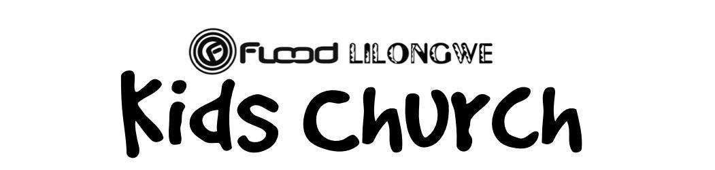

The Easter Story

Sunday Lesson Teaching Page

17th of May, 2020

Jesus Has Risen
The aim of this session is to: to celebrate that on the 3rd day Jesus rose from the dead and to continue to learn how very much that Jesus loves us and about salvation.
Verses: Matthew 27: 57-28:10
- Beginning Activities:
  - Today in our story there is an angel. I want you to draw a picture of what you think an angel looks like. Or if you wanted to make a paper plate angel you could.
  - Tell your parents the life cycles of butterflies and/or a frog. Talk about all the different changes that butterflies and frogs make. I want you to keep this in mind as we tell the Bible story today because we are talking about the different ways that Jesus was transformed.

- Storytime:
  - Read Matthew 27: 57-28:10
  - Watch the video that has been included.
  - Questions:
    - Where was Jesus buried (in Joseph of Arimathea’s tomb)
    - What was put in front of the tomb where Jesus was buried to make it secure? (Huge stone and guards)
    - On what day of the week was Jesus raised from the dead? (Sunday)
    - What happened as the women approached the tomb? (A violent earthquake shook the ground.)
    - What did the women see when they got to the tomb? (The rock was rolled away from the door of the tomb and an angel was sitting on top of it.)
    - What happened to the guards? (When they saw the angel, they were afraid and fell as if dead.)
    - What did the angel say to the women? (Do not be afraid and That Jesus had risen from the dead, just like Jesus said He would!)
    - What did the women do when they heard this Good News? (They were filled with joy and hurried to tell their friends.)
    - What did Jesus say when he met the women? (Do not be afraid. Go and tell the disciples that they will see me)
- Prayer/Response:
  - Why is the resurrection important?
- Jesus Redeemed us: Jesus was the ultimate, perfect, sinless sacrifice that paid the price for all sins – present, past, and future. His death gave us a clean slate and washed us clean.
- Jesus reconciled us to God: With our sins forgiven, we are able to enter into a right relationship as sons and daughters of our father in heaven.
- Jesus restored us: Without sin hanging over us, Jesus healed us from the brokenness of sin. As we get closer to God, we are restored to wholeness, and our lives are marked by grace and love. This process makes us able to see and work toward the purpose for which we were created. When we accept Jesus as our savior then we can have a personal relationship with him.
  - spend a few minutes talking about these things as a family. Then if you feel led, spend some time in prayer about one of these areas.
- Every day we are in a battle against sin and Satan. A lot of the time we forget to even fight! We let our sin defeat us and have the victory. We give into lying, anger, unkindness, disobeying parents, and lots of other sins! But we do not have to live like this! Because Christ has already won the victory and defeated sin, we know that we can defeat sin through His power. He makes us strong. Because He rose from the grave and defeated death, when we die, we are now able to live forever with Him!
  - Spend some time praising God for Jesus’ Resurrection and victory over sin and death! Everyone can take a time of sharing different praises and things they are thankful for.
- Ask God for faith and courage to trust Jesus and share the gospel with others.
  - Everyone share one person that you will be praying for and that there will be an opportunity to share the gospel with them.

- Craft:
  - Today we are going to continue making our comic strip that we made last week.
    - (attached below)
  - Today we are going to make shields of faith. Jesus’s victory over sin and death protects us like a shield.
  - Draw a picture of the empty tomb.

